**Section 2–4A: More Linear Equations**

Given the slope and *y*-intercept, you can write the equation of a line in slope-intercept form. You can also write the equation of a line in **point-slope form**.

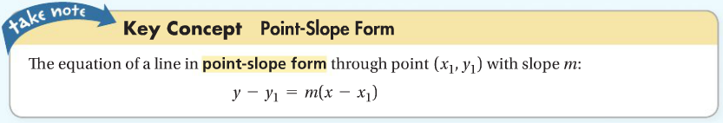

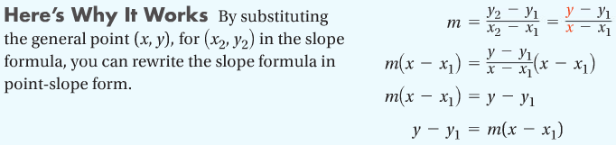

It is very easy to write any linear equation in point-slope form, because it only requires two items from the line: **one point from the line and the slope of the line**.

**Example 1: Writing an Equation Given a Point and the Slope**

A line passes through $(-5, 2)$ with slope $\frac{3}{5}$. What is an equation of the line?

**Question: Is slope-intercept or point-slope form more helpful for writing this equation?**

Since the slope and a point (not the *y*-intercept) are given, point-slope form is more helpful.

$y-y_{1}=m(x-x_{1})$ Substitute $m=\frac{3}{5}$ and $\left(x_{1}, y_{1}\right)=(-5, 2)$.

$y-2=\frac{3}{5}[x-\left(-5\right)]$ Simplify.

$y-2=\frac{3}{5}(x+5)$

**Example 2: Writing an Equation Given Two Points**

A line passes through $\left(3, 2\right)$ and $(5, 8)$. What is an equation of the line in point-slope form?

Let $\left(x_{1}, y_{1}\right)=(3, 2)$ and $\left(x_{2}, y_{2}\right)=(5, 8)$.

Substitute into the slope formula and simplify: $m=\frac{y_{2}-y_{1}}{x_{2}-x_{1}}=\frac{8-2}{5-3}=\frac{6}{2}=3$

Substitute into point slope form: $y-y_{1}=m(x-x_{1})$

$y-2=3(x-3)$

**Question: Does it matter which point you substitute into point-slope form?**

No, you can choose **either point** as $\left(x_{1}, y_{1}\right)$!!

Another form of the equation of a line is **standard form**, in which the sum of the *x* and *y* terms are set equal to a constant. When possible, **you should always write the coefficients of *x* and *y* and the constant term as integers**.

**Question: How can you rewrite the equation using only integer values?**

Multiply each side of the equation by the least common denominator of all fraction coefficients.



**Example 3: Writing an Equation in Standard Form**

What is an equation of the line $y=\frac{3}{4}x-5$ in standard form? Use integer coefficients.

$y=\frac{3}{4}x-5$ Subtract $\frac{3}{4}x$ from each side.

$-\frac{3}{4}x+y=-5$ Multiply each side by 4

$-3x+4y=-20$

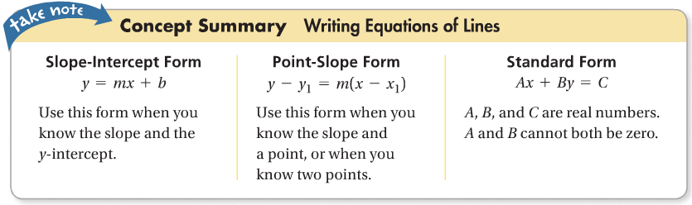

You can graph an equation in standard form quickly by determining the *x*- and *y*-intercepts and then drawing the line through them.

**Problem 4: Graphing an Equation Using Intercepts**

What are the intercepts of $3x+5y=15$? Graph the equation.

